Restoring Database

SSMS (SQL SERVER Management Studio)

**Step 1** − Connect to database

Step 2 – Choose database and right click and then click New Database. It shows following snapshot.

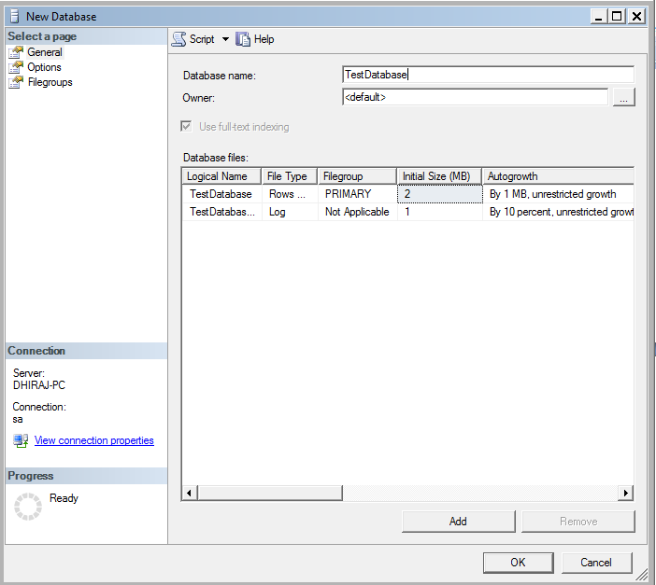

Type name of the database. e.g. say TestDatabase in the Database Name text box as shown above and click OK.

Step 3: Choose TestDatabase database and then right click it. Click Tasks -> Restore ->database as shown in the following snapshot.

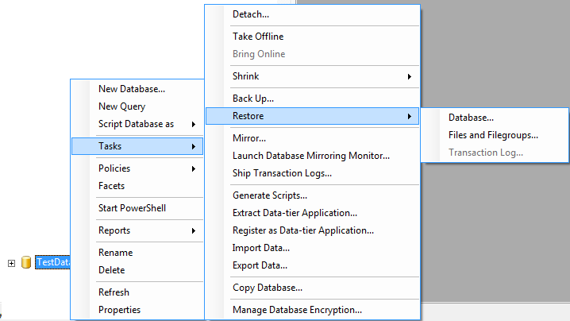

After click in Database it shows following snapshot.

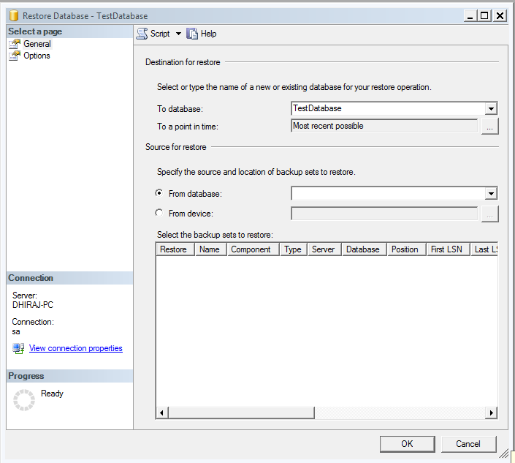

**Step 4** − Select **From device** radio button and click on as shown in above by arrow to select the backup file as shown in the following snapshot.

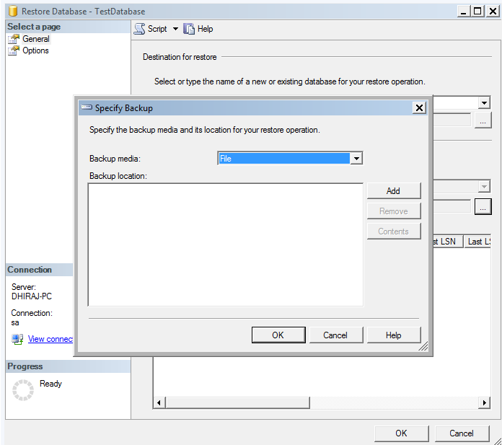

**Step 3** – Click on Add button and then choose the backup file from specified directory. After that Click OK and the following screen pops up.

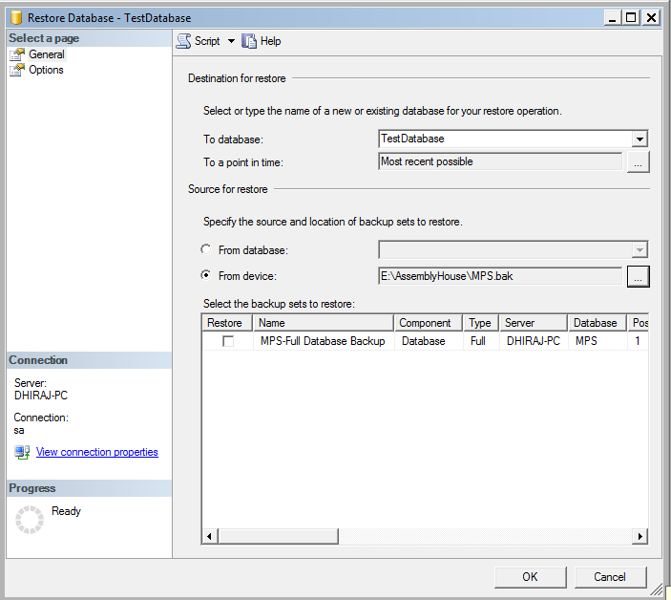

**Step 4** – Select Restore Check box as direction given by arrow.

**Step 5** − Select Options which is on the top left corner as shown in the following snapshot.

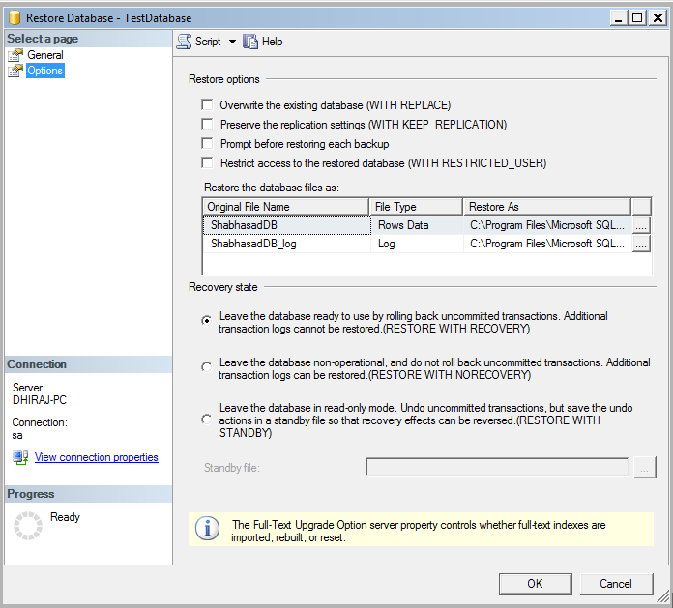

Step 6: Check the checkbox as shown by arrow and then click OK button. It Shows following snapshot.

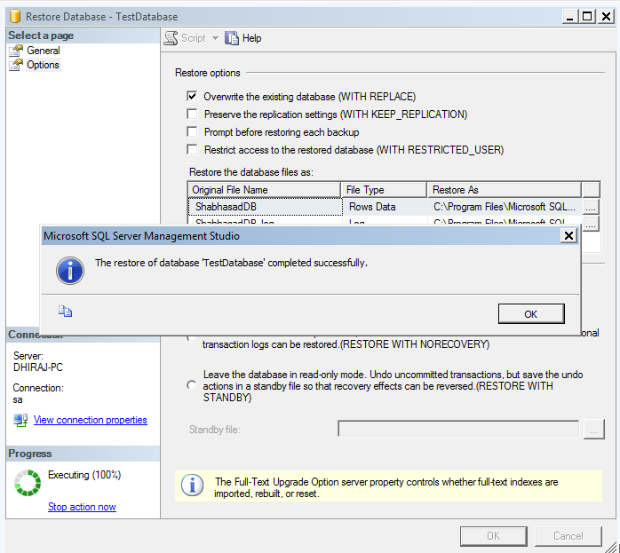

Click OK button.